Date: April 04, 2025

**ICT QUARTERLY MAINTENANCE REPORT**

|  |  |  |  |  |  |
| --- | --- | --- | --- | --- | --- |
| **PROPERTY NO.** | **TYPE** | **NAME** | **DATE** | **SERVICE RENDERED** | **REMARKS** |
| R4B-F501-223-C-02.014-19 | System Unit | Lorenzo R. Ambay Jr. | March 27, 2025 | Repair | Removed GPU Card |
| 2019-05-030-0001-F501-LFPS-R4B-04 | System Unit | Randy E. Magboo | March 27, 2025 | Repair | Removed GPU Card |
| N/A | Printer | Rhea G. Flores | March 20, 2025 | Repair | Initialized and Tested |
| 2018-05-030-0003-F501-LFPs-R4B-11 | System Unit | Hare Krisna Z. Roldan | March 10, 2025 | Repair | Replaced RAM |
| 2023-05-030-0001-F501-CARP-R4B-08 | Printer | Ysra Nica A. Arcon | March 12, 2025 | Repair | Fixed Paper Jam |
| 2022-05-030-012-F501-CARP-R4B-12 | Printer | Kay Jobelle Mahencio | March 12, 2025 | Repair | Reset Inkpad |
| 2023-05-030-0009-F501-COB-R4B-04 | Printer | Arnold Mascarenas | March 27, 2025 | Repair | Reset and Cleaned Ink Pad |
| 2022-05-030-014-F501-CARP-R4B-13 | Printer | Rose May F. Quinzon | March 11, 2025 | Repair | Reset and Cleaned Ink Pad |
| 2016-05-030-0001-F501-LFPs-R4B-09 | Printer | Ma. Isabel Beltran | March 31, 2025 | Repair | Fixed Paper Jam |
| 2013-05-030-0009-F501-COB-R4B-03 | Printer | Anna Kristel L. Talens | April 02, 2025 | Repair | Replaced Power Cord |
| 2021-05-030-0001-F501-LFPs-R4B-01 | Printer | Aileen Vernice G. Bahia | February 19, 2025 | Repair | Replaced Maintenance Box |
| 2017-05-030-0001-F501-CARP-R4B-04 | Printer | Rhen Mark L. Watiwat | February 24, 2025 | Repair | Cleaned Printer |
| 2024-05-030-0007-F501-LFPS-R4B-05 | Printer | Hanna Mitzi C. Capio | February 25, 2025 | Repair | Fixed Connection with the PC |
| 2019-05-030-0003-F501-LFPS-R4B-09 | Printer | Dyanne M. Jusi | February 19, 2025 | Repair | Reset and Cleaned Inkpad |
| R4B-F501-LFPS-223-C-DY.003-20 | Printer | Riz Windyl G. Lozano | March 12, 2025 | Repair | Reset Inkpad |
| 2020-05-030-0003-F501-LFPs-R4B-05 | Printer | Ma. Luzviminda B. Nilo | March 14, 2025 | Repair | Fixed Paper Jam |

Prepared by:

**ROY CARLO J. MALENAB**

Computer Services Programmer

Checked by:

**JIMMY V. LOZANO JR.**

Sr. Computer Services Programmer

Noted by:

**KIRSTY CAROLINE M. HERNANDEZ-ACERON**

Division Manager A, AFD

JUB

April 15, 2025

**RONILIO M. CERVANTES**

**Regional Manager A**

**NIA MIMAROPA Region**

Bayanan II, Calapan, Oriental Mindoro

Sir:

This is to forward the 2025 1st Quarter Maintenance Report for your review and approval.

Please acknowledge upon receipt.

Thank you and more power!

Respectfully yours,

**JIMMY V. LOZANO JR.**

Sr. Computer Services Programmer

**SUPPLY AND DELIVERY OF IT EQUIPMENT, SOFTWARE INSTALLATION AND LICENSE ACTIVATION**

**P.O. NO. 2025.03-050**

**DELIVERY DATE: APRIL 14,2025**

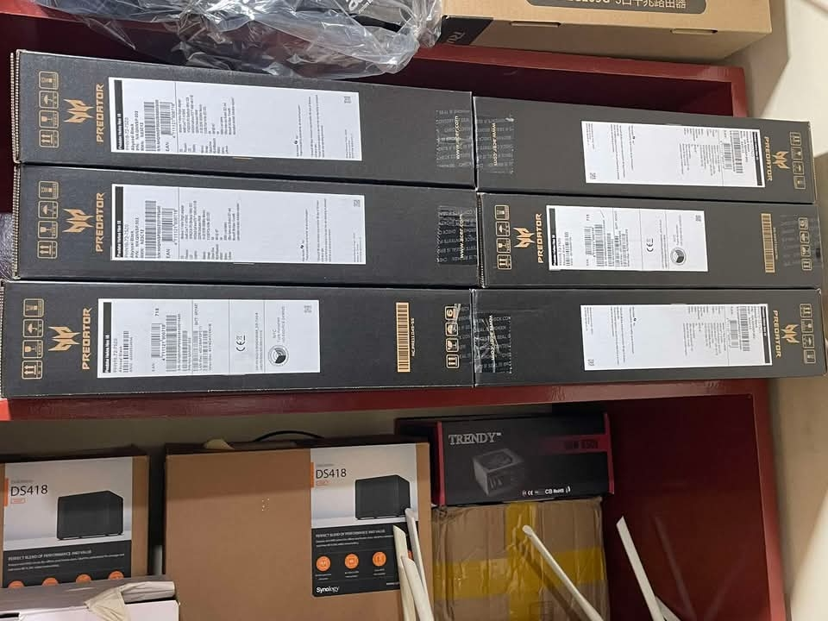

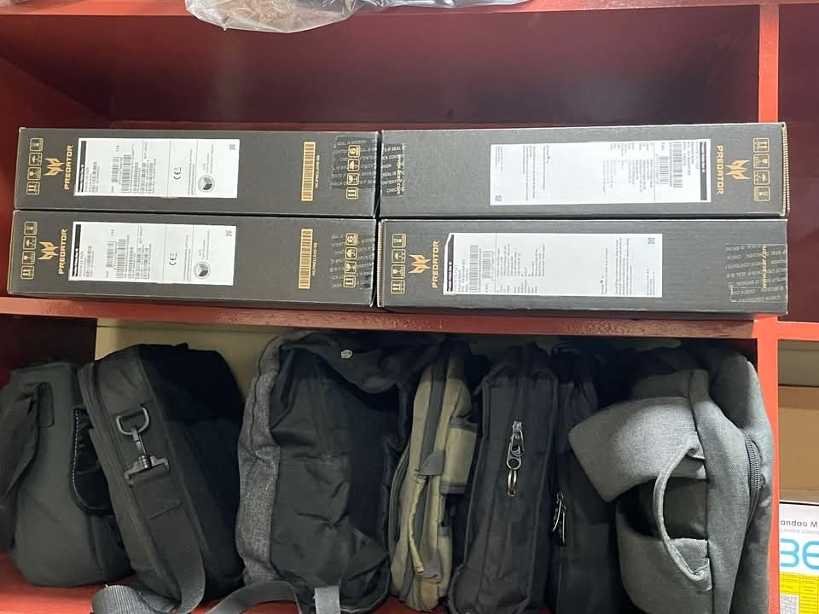

**SUPPLY AND DELIVERY OF IT EQUIPMENT, SOFTWARE INSTALLATION AND LICENSE ACTIVATION**

**P.O. NO. 2025.03-050**

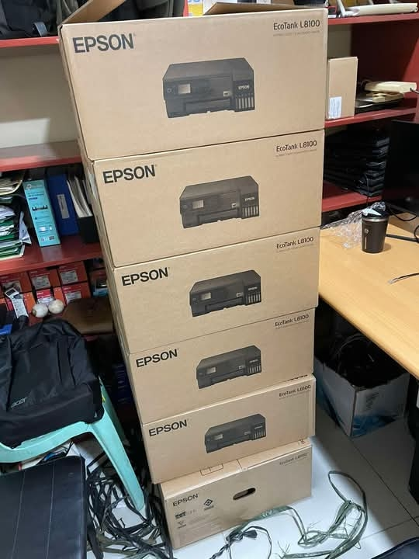**DELIVERY DATE: APRIL 14,2025**

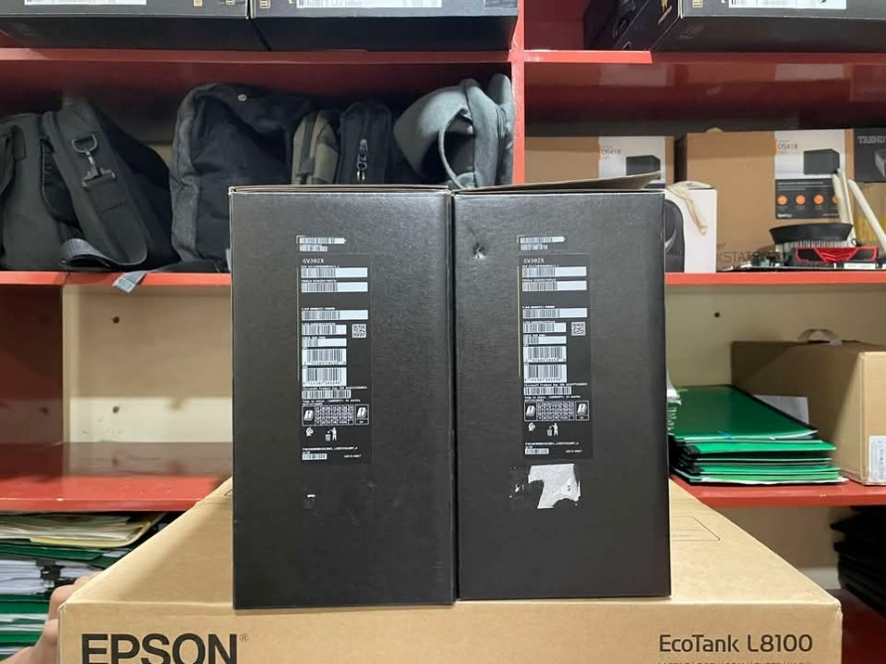

**SUPPLY AND DELIVERY OF IT EQUIPMENT, SOFTWARE INSTALLATION AND LICENSE ACTIVATION**

**P.O. NO. 2025.03-050**

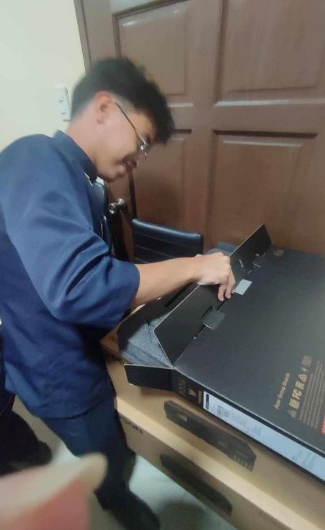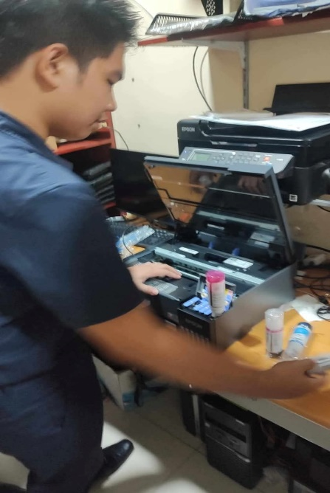**DELIVERY DATE: APRIL 14,2025**

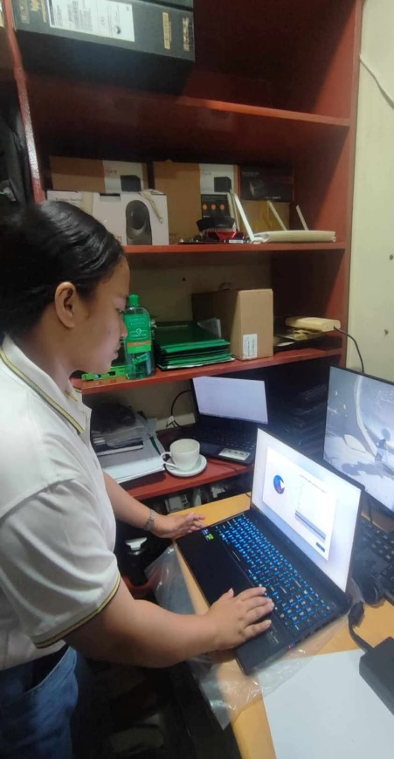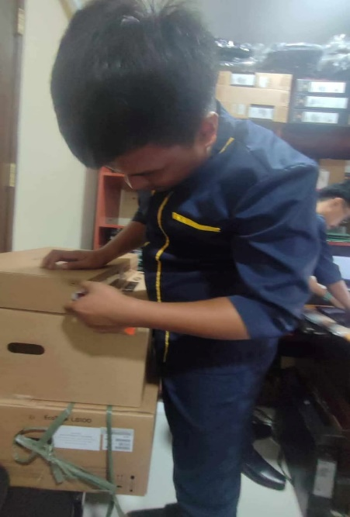

Prepared by:

**JIMMY V. LOZANO JR.**

Sr. Computer Services Programmer/

Inspector for ICT

April 15.2025

**CCTV REVIEW REPORT**

**FOR VALIDATION OF BIOMETRIC ATTENDANCE**

|  |  |  |  |
| --- | --- | --- | --- |
| **Employee** | **Date** | **Time** | **Remarks** |
| Castillo, Angelica M. | March 31,2025 | 5:00-6:30 PM | No CCTV footage of Ms. Castillo to PM out |
| April 10,2025 | 6:18 PM | Ms. Castillo forgot to Log Out |

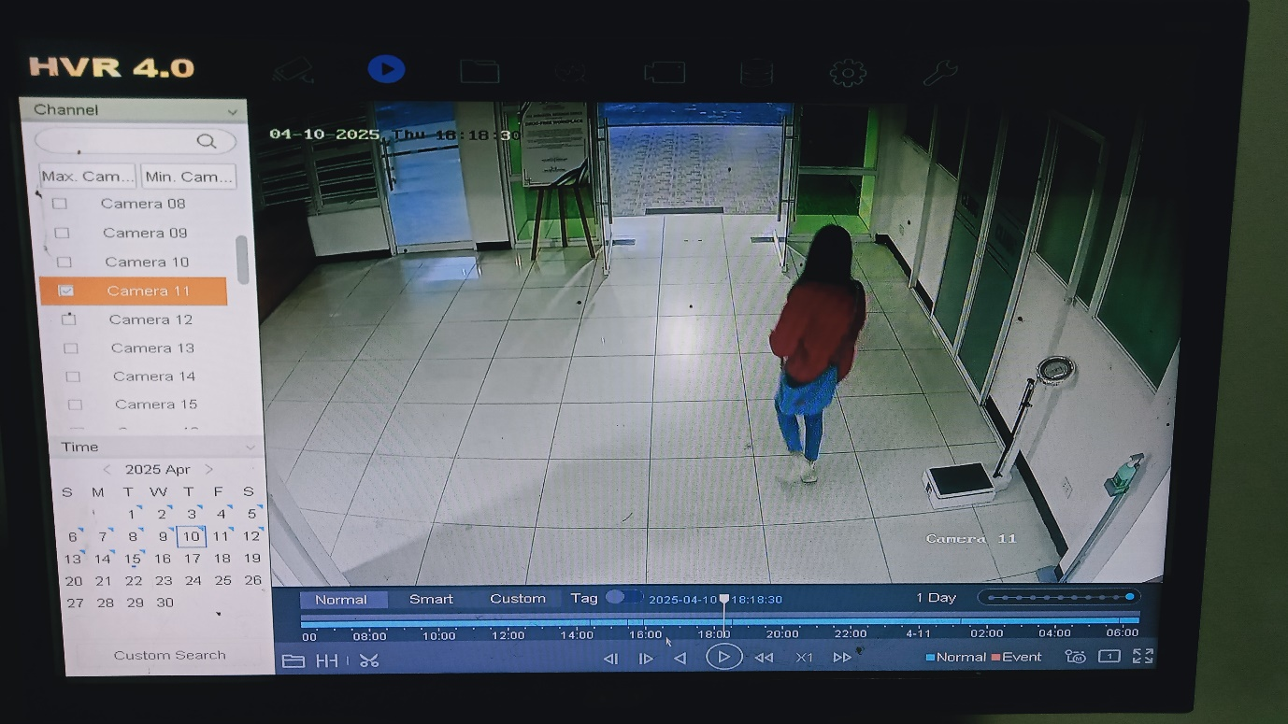

Prepared by:

**JIMMY V. LOZANO JR.**

Sr. Computer Services Programmer/

Inspector for ICT

**May 9,2025**

**CCTV REVIEW REPORT**

**FOR VALIDATION OF BIOMETRIC ATTENDANCE**

|  |  |  |  |
| --- | --- | --- | --- |
| **Employee** | **Date** | **Time** | **Remarks** |
| Malenab Roy Carlo J. | April 14,2025 | 12:43 PM In | Forgot to Log In |

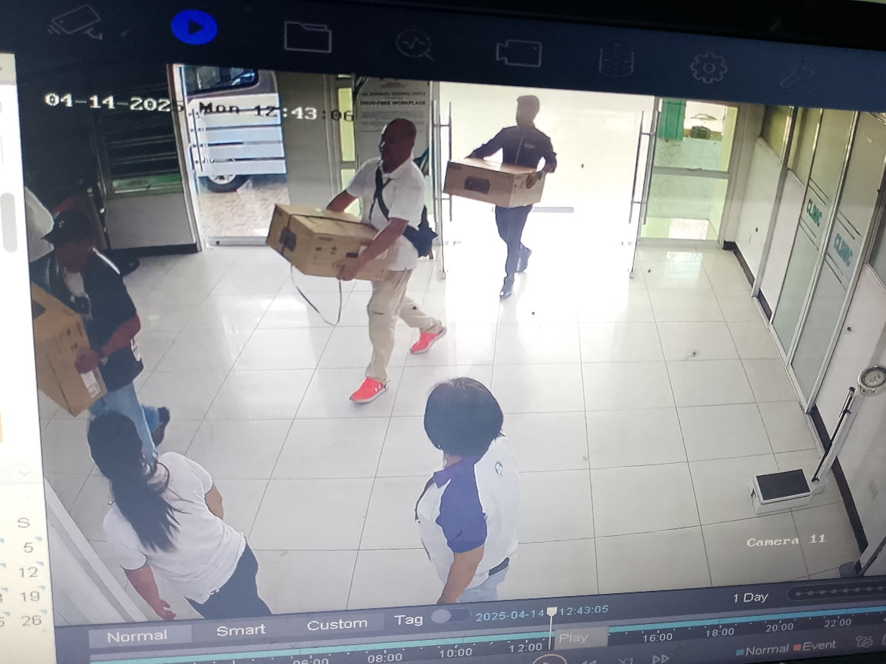

Prepared by:

**JIMMY V. LOZANO JR.**

Sr. Computer Services Programmer/

Inspector for ICT